# Project: Analyzing a Market Test

## Step 1: Plan Your Analysis

*To perform the correct analysis, you will need to prepare a data set. (500 word limit)*

*Answer the following questions to help you plan out your analysis:*

1. What is the performance metric you’ll use to evaluate the results of your test?

For this analysis, we will be using the gross margin of sales as the performance metric.

1. What is the test period?

The test period is between April 29, 2016 and July 21, 2016

1. At what level (day, week, month, etc.) should the data be aggregated?

Data will be aggregated by the week

## Step 2: Clean Up Your Data

*In this step, you should prepare the data for steps 3 and 4. You should aggregate the transaction data to the appropriate level and filter on the appropriate data ranges. You can assume that there is no missing, incomplete, duplicate, or dirty data. You’re ready to move on to the next step when you have weekly transaction data for all stores.*

## Step 3: Match Treatment and Control Units

*In this step, you should create the trend and seasonality variables, and use them along with you other control variable(s) to match two control units to each treatment unit. Note: Calculate the number of transactions per store per week to calculate trend and seasonality.*

*Apart from trend and seasonality...*

1. What control variables should be considered? Note: Only consider variables in the RoundRoastersStore file.

The control variables that were considered for this analysis were Sq_Ft and AvgMonthSales.

1. What is the correlation between your each potential control variable and your performance metric?

Below is a table with the Pearson Correlation between the potential control variables (Sq_Ft and Avg MonthSales) and the performance metric (Gross Margin).

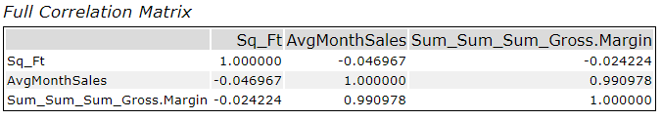

1. What control variables will you use to match treatment and control stores?

Because the Sq_Ft variable has a negative correlation with the Gross Margin and the AvgMonthSales variable has a positive with the Gross Margin, we will be using the AvgMonthSales variable to match our treatment and control stores.

1. Please fill out the table below with your treatment and control stores pairs:

|  |  |  |
| --- | --- | --- |
| Treatment Store | Control Store 1 | Control Store 2 |
| 1664 | 7162 | 8112 |
| 1675 | 1580 | 1807 |
| 1696 | 1964 | 1863 |
| 1700 | 2014 | 1630 |
| 1712 | 8162 | 7434 |
| 2288 | 9081 | 2568 |
| 2293 | 2568 | 12219 |
| 2301 | 3102 | 9238 |
| 2322 | 2409 | 3235 |
| 2341 | 12536 | 2383 |

## Step 4: Analysis and Writeup

*Conduct your A/B analysis and create a short report outlining your results and recommendations. (250 words limit)*

*Answer these questions. Be sure to include visualizations from your analysis:*

1. What is your recommendation - Should the company roll out the updated menu to all stores?

Based on the A/B Analysis, the company should roll out the updated menu to all stores. Management was looking for an 18% increase in profit growth for the treatment stores compared to the comparative period compared to the control stores and our treatment stores. In each region and overall, we have shown increases greater than 18%

1. What is the lift from the new menu for West and Central regions (include statistical significance)?

For the Central Region, we found that the lift was 43.5% with a 99.5% significance level. The A/B Analysis information is shown below.



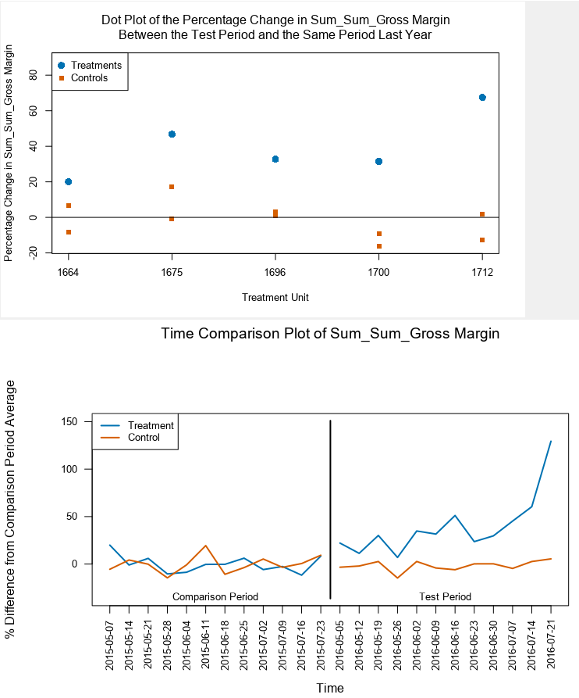

For the West Region, we had a lift of 37.9% with a 99.5% significance level. The A/B Analysis is shown below.



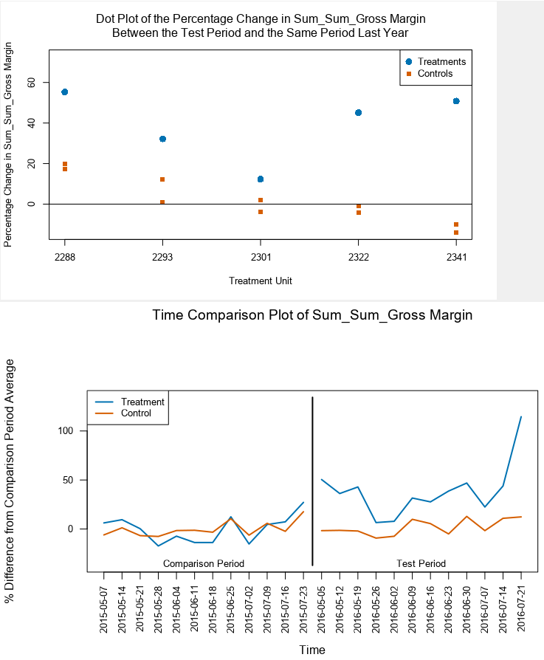

1. What is the lift from the new menu overall?

For the new menu overall, we have a lift of 40.7%.



